V Data link layer packs bits into frames.
A frame will look like the following: 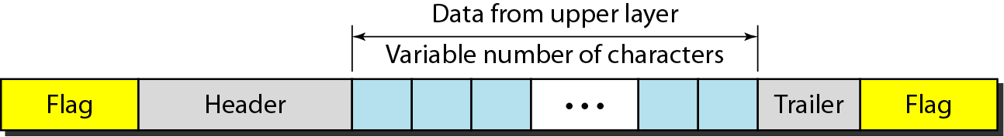
Byte stuffing is the process of adding a extra byte to where an indicated flag is or escape character. Bit stuffing is adding an extra zero after 5 consecutive 1s.
Most important of datalink is flow control and error control, these are known as data link control.
Flow control is the set of procedures used to restrict the amount of data that the sender can send before waiting for acknowledgment. Error controls is based on ARQ (automatic repeat request), which is the transmission of data.
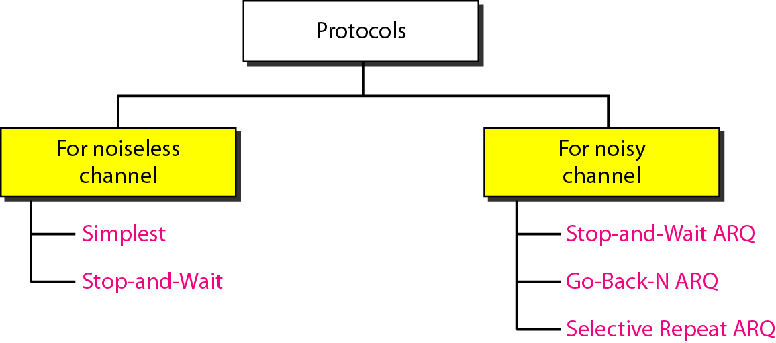
Noiseless stop and wait

Stop and wait is the same for both noiseless and a noisy channel, except in the acknowledgement it puts a sequence for the ARQ/noisy.

In the Go-Back-N Protocol, the sequence numbers are modulo 2^m -1, where m is the size of the sequence number field in bits. There is a sending window, if the sender does not receive acknowledgement for the frames that have been sent and the sender reaches the end of the sending window it will then restart at the beginning of the window.
Selective repeat arq, sends the frames one after the other, If the receiver for some reason receives a frame that is not in the sequence order it will send back a NAK which will then notify the sender that something messed up and it will restart at the lost frame.2 ^(m-1)
HDLC – High level data link controlis a bit-oriented protocol for communication over point-to-point and multipoint links.

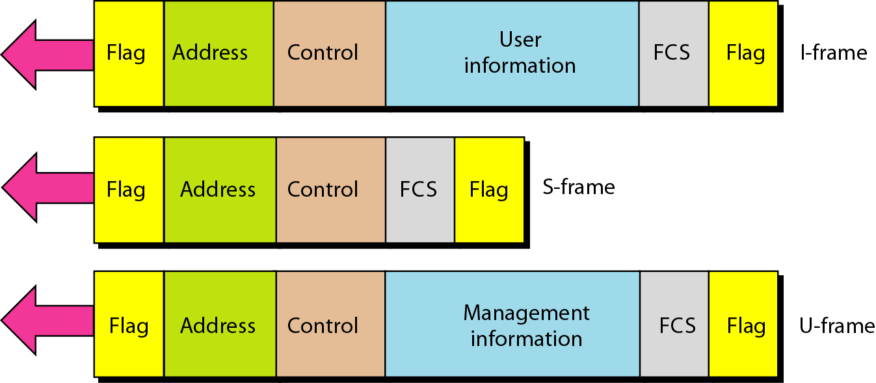
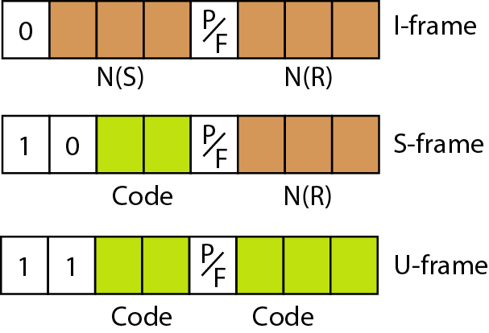

Checksum
Sender Side
Take Packet Split into 4 bit sections
Add them all together
Anything that exceeds 4 bits gets wrapped around and added again
Take ones compliment and that gives ur checksum that the receiver would use
Receiver Side
Take the packet and split into 4 bit sections again
Add them all together
Instead of wrapping around you add the checksum
Then wrap around and add
Takes ones compliment of that and it should be all zeroes if no errors.

